# Grade prediction and performance application

Part A – Requirements

## Functional requirements summary

<R1>The software allows the user to build a course.</R1>

<description>The user is able to build a course in order to find out the outcome of his degree, real or by predicting marks.</description>

<R2>The software shall allow the user to record the name of the course.</R2>

<description>The student is able to add the course name. The user should be able to change the name of the course, for example, when a student decides to switch to a different course.</description>

<R3>The software shall allow the user to add modules to the course.</R3>

<description>The student can create modules and add them to the course.</description>

<R4>The software shall allow the user to add a credit value to each module.</R4>

<description>Each module has a credit value. Most of them are 15 credits but there are also modules with 30 credits. There is also a final year project worth 45 credits. Therefore, the user should be able to add a credit value to the each module.</description>

<R5>The software shall allow the user to input assessments(tutorial, coursework, exam) for each module.</R5>

<description>The user can add assessments to each module, including a tutorial exercise, coursework, exam et al. Each assessment has name and weight.</description>

<R6>The software should show the new module added.</R6>

<description>After each module entry, if everything is correct, the module will be shown in the software. However, some information can be deleted in case some of errors. For example if the assessments do not add up to 100% or invalid weight for assessments.</description>

<R7>The software shall allow the user to add modules until the course is complete.</R7>

<description>A course should be complete when the sum of 120 credits per year has been reached in all three years of study.</description>

<R8>The software shall allow the user to save the status of the course.</R8>

<description>The user should be able to save manually the status of the course using a save button. The software will also save automatically any changes on exit.</description>

<R9>The software shall continue from the last edit version.</R9>

<description>If the software is not at its first run, then it should use the existing data to build the interface and resume to the last edit stage.</description>

<R10>The software shall save the file changes in the background.</R10>

<description>The software will save changes in the background to simulate writing to a database.</description>

<R11>The software shall update any changes in the summary tab (level summary and main one) as the user edits any module details for the purpose of predicting the outcome of his degree.</R11>

<description></description>

<R12>The software shall allow the user to add modules for 3 years of study.</R12>

<description>The user can add modules for 3 years of study. Each module will have a credit amount. All modules should add to 120 credits per year.</description>

<R13>The software shall show results on each level summary.</R13>

<description>On a level summary the user can see the outcome of each module. For example: User Experience Design: 45% Pass or 35% Referral or 25% Fail.</description>

<R14>The software shall have a main Summary tab where the user can see the final outcome for each level of study and the final outcome of their degree.</R14>

<description>The main summary tab will cover all three levels of study with each percentage and the final outcome for the user’s degree. For example: level 4: 44%, level 5: 60% , level 6: 75%. Outcome: second upper class degree.</description>

<R15>The software shall allow the user to delete a course.</R15>

<description>The user is able to delete a course. The user might want to change the course. Or to create the final outcome for a friends’ degree without deleting his own data.</description>

<R16>The software shall allow the user to add the name of the student taking the course.</R16>

<description>The student or a friend of the student might want to find the outcome of their degree. They need to have a different name so that it could become distinctive on the table.</description>

<R17>The software shall allow the user to reset a year of study.</R17>

<description>When changing the course or for any other reason, the user shall be allowed to reset the year of study to make the data input easier. This will reset the year of study to 0 modules added.</description>

<R18>The software shall allow the user to delete the module and its assessments.</R18>

<description>If the student decided to drop a module, the student might want to delete the module and all it contains.</description>

<R19>The software shall allow the user to delete an assessment.</R19>

<description>The user might input data by mistake or might have added too many assessments. The user shall be allowed to delete an assessment. </description>

<R20>The software shall save changes to a database.</R20>

<description>The software shall save changes to a database either manual or automatically.</description>

## Non functional requirements

<NF1>The software should not crash under any user input.</NF1>

<description>The user is asked to input lots of data. The software should be aware of the possibility of having negative numbers, instead of positive, strings instead of integers, et al.</description>

<NF2>The software should be able to recover from previous versions in case of a crash.</NF2>

<description>In case the software doesn’t manage all the errors, it should recover from the previous version without having to input all the data again.</description>

<NF3>The capacity of the app should not be limited.</NF3>

<description>The user can create more than one course entry. In this case it can be used by lecturers and university staff as well.</description>

<NF4>The application should be secure.</NF4>

<description>The application holds personal information given by the user, so it should be secure in order to conform with the data protection act.</description>

<NF5>The response time should be minimum.</NF5>

<description>The software should be optimised in order to minimize the time response.</description>

<NF6>The software should be managed easily.</NF6>

<description>The software should be easily managed by any user with no prior experience with it. Should also be intuitive.</description>

<NF7>The software should be run on a machine with internet connection.</NF7>

<description>The software should be used on a machine with internet connection to enable reading and writing from and to a database.</description>

# Part B – Use Case Diagrams

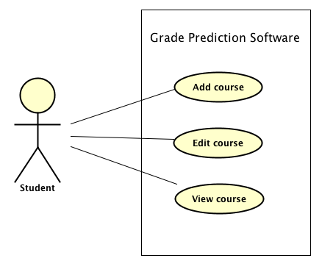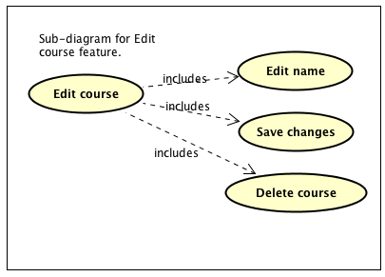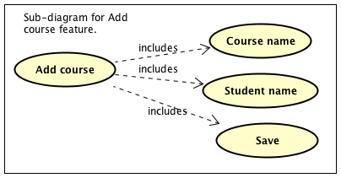

# Use case scenario 1

**Use Case:** Add course

**Id:** UC-001

**Description:** The user opens the Grade Prediction Software. There are no courses added. The user adds a course as Multimedia Computing for the Eduard student and saves it.

**Level:** High Level Summary

**Primary actor:** Student – Eduard

**Supporting actors:** Course leader

**Stakeholders and Interests:** University

**Pre-conditions:**

* The system needs to have a stable internet connection.
* The user needs to know the Course title and the Student’s name.

**Post conditions:**

* In order to create a valid course entry, the user needs to input valid characters for a course and student names.
* To be able to create a valid course entry, the user needs to enter values that have not been used before in the same combination (same course and same name twice – not accepted. Same name used but on a different course – accepted).

**Trigger:** The user wants to create a Grade prediction for his own course.

# Main success scenario

1. The user has opened the Grade prediction software.

2. Using a stable internet connection, the software has connected to the database and found that this is the first time the user has opened the software. There are no previous versions to which the software should be restored. The connection to the database has been closed.

3. The user decided to create a new course.

4. The software asks for the Course title and Student name.

5. The user added entries for both course and student names and saved.

6. The software validated the entries and saved the course entry.

7. The software connects to the database, saves the changes and closes the connection to the database.

8. The software updates the summary view.

Variations

* not required

# Use case scenario 2

**Use Case:** Edit course

**Id:** UC-002

**Description:** The user has opened the Grade Prediction Software. There is at least one course added. The student has changed degrees, so the user wants to change the course name.

**Level:** High Level Summary

**Primary actor:** Student

**Supporting actors:** Course leader

**Stakeholders and Interests:** University

**Pre-conditions:**

* The system needs to have a stable internet connection.
* At least one course entry needs to be created already.
* The user needs to know the Course title.

**Post conditions:**

* In order to create a valid course entry, the user needs to input valid characters for a course and student names.
* To be able to create a valid course entry, the user needs to enter values that have not been used before in the same combination (same course and same name twice – not accepted. Same name used but on a different course – accepted).

**Trigger:** The student changed his previous course to a new one.

# Main success scenario

1. The user has opened the Grade prediction software.

2. Using a stable internet connection, the software has connected to the database and found that this is not the first time the user has opened the software. There is a previous version to which the software is being restored. The connection to the database has been closed.

3. The user decided to edit the course.

4. The software asks for the Course title and Student name.

5. The user edited the entry for the course, left the student name as it was and saved.

6. The software validated the entries and saved the course entry.

7. The software connects to the database, saves the changes and closes the connection to the database.

8. The software updates the summary view.

Variations

not required

# Use case scenario 3

**Use Case:** View course

**Id:** UC-003

**Description:** The user has opened the Grade Prediction Software. There is at least one course added. The student wants to view the course to add extra details, to check the status of their degree or to start a prediction.

**Level:** High Level Summary

**Primary actor:** Student

**Supporting actors:** Course leader

**Stakeholders and Interests:** University

**Pre-conditions:**

* The system needs to have a stable internet connection.
* At least one course entry needs to be created already.

**Post conditions:** none

**Trigger:** The student wants to view the course to add extra details, to check the status of their degree or to start a prediction.

# Main success scenario

1. The user has opened the Grade prediction software.

2. Using a stable internet connection, the software has connected to the database and found that this is not the first time the user has opened the software. There is a previous version to which the software is being restored. The connection to the database has been closed.

3. The user decided to view the course.

4. The software shows the course details.

Variations

not required

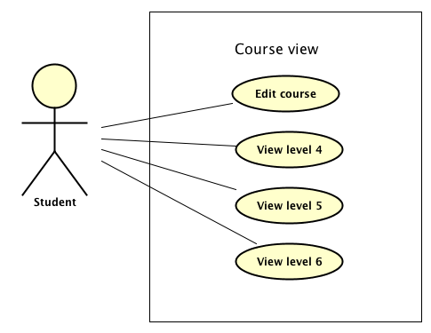

# Use case scenario 4

**Use Case:** View level

**Id:** UC-004

**Description:** The student is viewing the course details. In order to add more details, to check the degree status or to make a prediction, the user will click to view one of the levels (4,5 or 6).

**Level:** High Level Summary

**Primary actor:** Student

**Supporting actors:** Course leader

**Stakeholders and Interests:** University

**Pre-conditions:**

* The system needs to have a stable internet connection.
* At least one course entry needs to be created already.

**Post conditions:** none

**Trigger:** The student wants to view a particular level (4,5 or 6) to add extra details, to check the status of their degree or to start a prediction.

# Main success scenario

1. The software shows the course details.

2. The user selected a level to view.

3. The software shows the level details.

Variations

not required

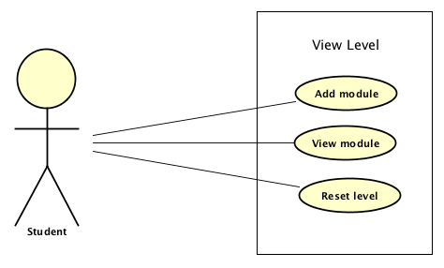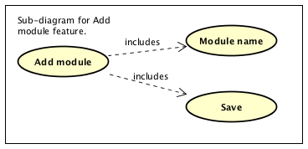

# Use case scenario 5

**Use Case:** Add module

**Id:** UC-005

**Description:** The student is viewing the level details. The user wants to add a new module.

**Level:** High Level Summary

**Primary actor:** Student

**Supporting actors:** Module leader

**Stakeholders and Interests:** University

**Pre-conditions:**

* The system needs to have a stable internet connection.
* The user needs to know the module title.

**Post conditions:**

* In order to create a valid module entry, the user needs to input valid characters for a module name.

**Trigger:** The user wants to create a new module in order to build the degree and get an outcome or prediction.

# Main success scenario

1. The student is viewing the level details.

2. The user decided to create a new module.

3. The software asks for the module title.

4. The user added an entry for module name and saved.

5. The software validated the entry and saved the module entry.

6. The software connects to the database, saves the changes and closes the connection to the database.

7. The software updates the summary view.

Variations

* not required

# Use case scenario 6

**Use Case:** View module

**Id:** UC-006

**Description:** The student is viewing the level details. The user wants to view a module details.

**Level:** High Level Summary

**Primary actor:** Student

**Supporting actors:** Module leader

**Stakeholders and Interests:** University

**Pre-conditions:**

* The system needs to have a stable internet connection.

**Post conditions:** none

**Trigger:** The user wants to view a module details.

# Main success scenario

1. The student is viewing the level details.

2. The user decided to view a particular module.

3. The software shows the module details.

Variations

* not required

# Use case scenario 7

**Use Case:** Reset module

**Id:** UC-007

**Description:** The student is viewing the level details. The user wants to reset the level and all its modules to make it easy to edit a course when the student changes degrees.

**Level:** High Level Summary

**Primary actor:** Student

**Supporting actors:** Course leader

**Stakeholders and Interests:** University

**Pre-conditions:**

* The system needs to have a stable internet connection.

**Post conditions:** none

**Trigger:** The user wants to reset the level and all its modules.

# Main success scenario

1. The student is viewing the level details.

2. The user decided to reset the level with all its modules.

3. The software asks for if the user is sure.

4. The user confirms the reset of that particular level.

5. The software resets the level (the modules are being dropped with all assessments connected to them) and saves the changes.

6. The software connects to the database, saves the changes and closes the connection to the database.

7. The software updates the summary view.

Variations

* not required

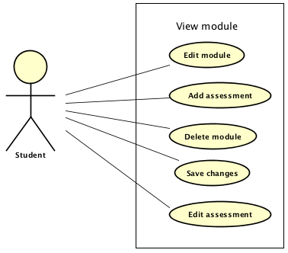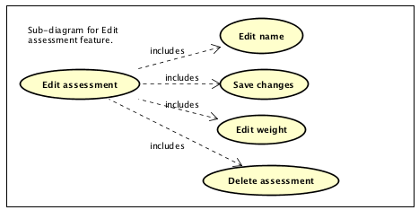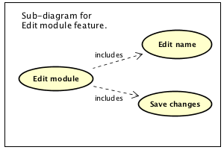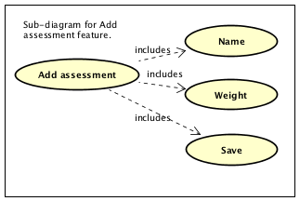

# Use case scenario 8

**Use Case:** Edit module

**Id:** UC-008

**Description:** The student has requested to change an optional module with another. The user will change the name of that certain module. This feature can also be used when a module title is mistyped.

**Level:** High Level Summary

**Primary actor:** Student

**Supporting actors:** Course leader

**Stakeholders and Interests:** University

**Pre-conditions:**

* The system needs to have a stable internet connection.
* At least one course entry needs to be created already.
* At least one module entry needs to be created already.
* The user needs to know the new module title.

**Post conditions:**

* In order to create a valid module entry, the user needs to input valid characters for a module name.

**Trigger:** The student has requested to change an optional module with another or the student wants to correct mistyping errors.

# Main success scenario

1. The user decided to edit the module.

2. The software asks for the module title.

3. The user edited the entry for the module and saved.

4. The software validated the entry and saved the module.

5. The software connects to the database, saves the changes and closes the connection to the database.

6. The software updates the summary view.

Variations

* not required

# Use case scenario 9

**Use Case:** Add assessment

**Id:** UC-009

**Description:** The student is viewing the module details. The user wants to add a new assessment.

**Level:** High Level Summary

**Primary actor:** Student

**Supporting actors:** Module leader

**Stakeholders and Interests:** University

**Pre-conditions:**

* The system needs to have a stable internet connection.
* The user needs to know the assessment details.

**Post conditions:**

* In order to create a valid assessment entry, the user needs to input valid characters for an assessment name and weight.

**Trigger:** The user wants to create a new assessment in order to build the module and get an outcome or prediction.

# Main success scenario

1. The student is viewing the module details.

2. The user decided to create a new assessment.

3. The software asks for the assessment name and weight.

4. The user added an entry for assessment name, weight and saved.

5. The software validated the entry and saved the assessment entry.

6. The software connects to the database, saves the changes and closes the connection to the database.

7. The software updates the summary view.

Variations

* not required

# Use case scenario 10

**Use Case:** Delete module

**Id:** UC-010

**Description:** The student is viewing the module details. The user wants to delete the module in order to add a new one in its place. In order for this to work, the user has to save the changes.

**Level:** High Level Summary

**Primary actor:** Student

**Supporting actors:** Module leader

**Stakeholders and Interests:** University

**Pre-conditions:**

* The system needs to have a stable internet connection.

**Post conditions:** none

**Trigger:** The user wants to delete the module in order to add a new one in its place.

# Main success scenario

1. The student is viewing the module details.

2. The user decided to delete the module.

3. The software marks the module to be deleted.

4. The user saves the changes.

5. The software deletes the module and all the assessments that it holds.

6. The software connects to the database, saves the changes and closes the connection to the database.

7. The software updates the summary view.

Variations

* not required

# Use case scenario 11

**Use Case:** Edit assessment

**Id:** UC-011

**Description:** The student is viewing the module details. The user wants to edit one of the existing assessments for the prediction reasons or for correcting mistypes.

**Level:** High Level Summary

**Primary actor:** Student

**Supporting actors:** Module leader

**Stakeholders and Interests:** University

**Pre-conditions:**

* The system needs to have a stable internet connection.
* The user needs to know the assessment details.

**Post conditions:**

* In order to create a valid assessment entry, the user needs to input valid characters for an assessment name and weight.

**Trigger:** The user wants to edit one of the existing assessments for the prediction reasons or for correcting mistypes.

# Main success scenario

1. The student is viewing the module details.

2. The user decided to edit an existing assessment.

3. The software asks for the assessment name and weight.

4. The user added an entry for assessment name, weight and saved.

5. The software validated the entry and saved the assessment entry.

6. The software connects to the database, saves the changes and closes the connection to the database.

7. The software updates the summary view.

Variations

* not required

# Part C – Classes

|  |  |
| --- | --- |
| Class name | Description |
| 1. EntryPoint | This will create a form to hold the courses an user can select and edit. |
| 1. Course | This will create a form that holds the course. It will automatically create 3 levels (4,5,6). On the view it will have links towards all three levels and will also display the average for each level. |
| 1. Module | This will create a form that will hold the module. It will also hold any assessment the user will create for the module. It will display the assessments, results and the final outcome for the module. |
| 1. Assessment | This will create a form that will have name and weight as fields. |
| 1. Summary | This will create a form that holds all details the user has input and will be updated accordingly after each input. |
| 1. Database | This will establish the connection to the database. |
| 1. Level | This will create a form that will hold modules. |
| 1. Sanitizer | This class will make sure there all the characters are valid inside a string or int. |
| 1. InterfaceSave | This interface will make all forms that have a save button to: save in the back end, update the database, update current form, update summary. |
| 1. InterfaceDelete | This interface will make all forms that have a delete button to: remove everything in the GUI, update the summary, drop the objects supposed to be deleted, update the database. |
| 1. Controller | This class will make sure everything will run smooth by managing all the above. |

|  |  |  |  |
| --- | --- | --- | --- |
| Class name | Type | Responsibility | Collaborations |
| EntryPoint | Model | Holds all the courses that have been created. | Courses, Database, Controller |
| CreateEntryPointView | View(Form) | View for the main screen of the application. | CreateEntryPointViewController |

|  |  |  |  |
| --- | --- | --- | --- |
| Class name | Type | Responsibility | Collaborations |
| Course | Model | Creates 3 levels (4,5,6) and keeps all final stats for them. | Level, Database, Controller |
| CreateCourseView | View(Form) | View for the main screen of the application. | CreateCourseViewController |